12

Standard multiple regression

Multiple regression in R

To illustrate multiple regression in R, we will use the data that we used previously to illustrate simple linear regression in Chapter 11. Remember, you need to set these data out in Excel as we have done in Screenshot 1:

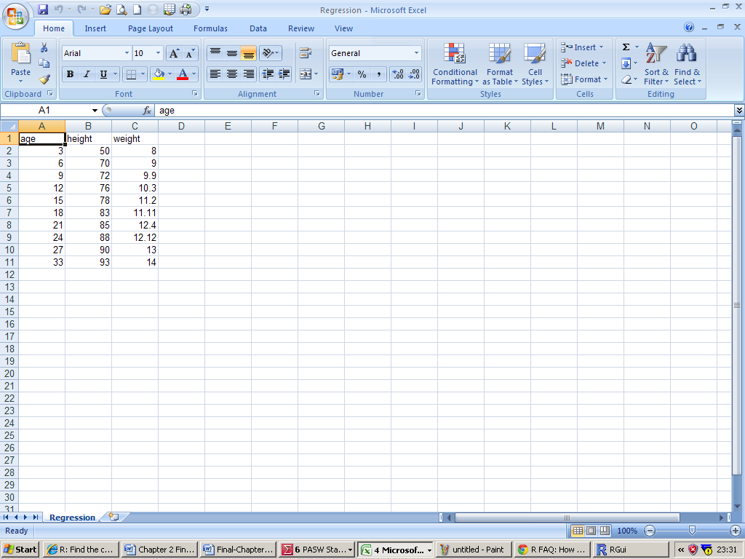
Screenshot 1

Here you can see that we have three variables, ‘age’, ‘height’ and ‘weight’. In this analysis, we are going to look to see how well each of age and height predict weight. Thus, weight is our criterion or dependent variable and age and height are our predictor or independent variables. We have imported this data into R and assigned it to the data frame called ‘MRegr’. We have also used the attach() command to make referring the variables in the data frame easier.

Now, to run the multiple regression we use the lm() command in a similar way to that described in Chapter 11, but this time we add in an extra variable to the regression analysis:

>summary(lm(weight~age + height))

When you run this command, you will be presented with the output illustrated in Screenshot 2:

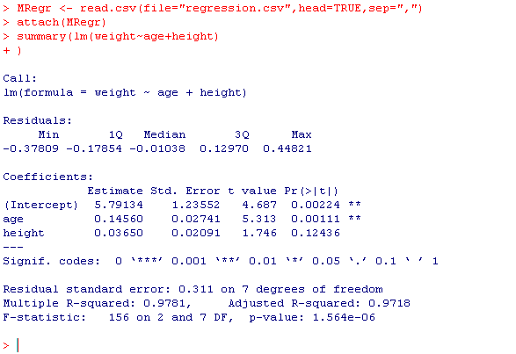Screenshot 2

Here you should be able to see that there is overall a significant relationship between the predictor variables age and height with weight. This has an F-value of 156, with 2 and 7 degrees of freedom and an associated p-value < .001. The R-square statistic of 0.98 suggests that 98% of the variation in weight is accounted for by participants’ age and height (but the adjusted R-square gives a more realistic estimate of this and this is a value of 0.97). The unstandardised regression coefficient for age is 0.15 and this has a t-value of 5.31 and an associated p-value of .001. The coefficient for height is 0.04, with a t-value of 1.75 which has an associated p-value of .12. Thus, there is a significant overall relationship between the predictors and weight but only age has a significant unique relationship with weight.

The regression equation can be generated from the output in Screenshot 2. Remember we take the values from the ‘Estimate’ column in the output, thus the regression equation for predicting weight from both age and weight would be:

weight = 5.79 + 0.15 * age + 0.04 * height

Remember, if we want the standardised regression coefficients, we need to standardise all of the variables in the regression analysis using the scale() command, thus:

>summary(lm(scale(weight)~scale(age) + scale(height)))
Would give you the output presented in Screenshot 3:

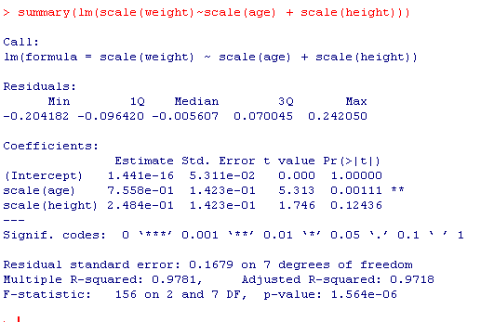
Screenshot 3
Here you can see that we have a standardised regression of 0.76 coefficient for age and for height it is 0.25. Remember R presents some information using scientific notation and so the ‘e-01’ after the number means move the decimal place 01 places to the left.

